European R+I Days: Clean Sky creating and leveraging synergies across Europe

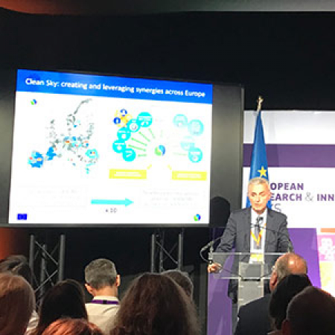

24 September 2019

Clean Sky’s Executive Director Axel Krein discussed Clean Sky’s work on smart specialisations with European regions as part of a panel session during the European R+I Days 2019, the European Commission’s key event focusing on research and innovation.

The panel, titled ‘Synergy labels: a catalyst for additional funding opportunities’, also featured speakers from the European Commission’s Directorate-General for Research and Innovation, BBI Joint Undertaking, and the EBRD (European Bank for Reconstruction and Development), who discussed the best ways to capitalise on Horizon 2020 proposals which are of high quality but which do not receive funding due to budgetary restrictions.

Clean Sky is working closely together with European regions to support their smart specialisation strategies and priorities which are often closely linked to Clean Sky scope and objectives (e.g. smart mobility, clean technologies, aeronautics, aerospace, advanced manufacturing etc.). This is underpinning and supporting EU regional and social policies. 18 Memoranda of Understanding (MoU) have been signed with regions and Member States across Europe, and these MoU have triggered over 35 complementary projects. For example, regional calls have been launched by Campania (Italy) with a dedicated budget for aeronautics projects linked to Clean Sky priorities, and by Occitanie (France); and national calls by the Czech Republic and Romania.

Learn more about Clean Sky’s work with regions and Member States [here](https://www.cleansky.eu/structural-funds-and-regions).